|  |  |
| --- | --- |
| Don't Be A Kidnapper | ::Logos:CNB-Logo-Wide.pdf |

**Fledgling Birds Usually Don't Need Rescued**

I found a baby bird, fully feathered, but cannot fly? Does he need rescued?

This is the situation that we receive the most calls about during the baby bird season.

**Fledgling songbirds leave the nest BEFORE they’re able to fly.**In much the same way human toddlers must crawl before they can run, songbirds hop and walk around a few days before they’re able to fly.  The majority of fledgling songbirds are well feathered on their body with short wing and tail feathers; they’re able to stand, walk and hop; they may be able to make short flights from branch to branch or from the ground up to low branches; and they are vocal and still dependent on their parents for care.  During this stage they are commonly observed on the ground, out in the open, on branches and in bushes - all over the place!

Although the parents may not be with their fledgling every second of the day, they remain in vocal contact at all times.  Additionally, the location where you observed the baby is the parents' territory, so they are always nearby.  Depending on the species, it will take between a few days and a few weeks before fledgling songbirds can fly well enough to attempt to keep up with their parents and evade danger. Fledglings are vulnerable and naïve at this stage of their development.  If you have outdoor cats, the kindest thing you can do for the birds is keep your cats indoors.

The exception to the fledgling rule is swallows, swifts, flycatchers and all cavity-nesting birds – these birds are fully feathered and flight capable when they leave the nest.  Any fledgling swallows, swifts, flycatchers or cavity nesters that cannot fly must be rescued.

If you need help with the bird's identification text us a photo at 303-618-0357 AND via a Facebook message.

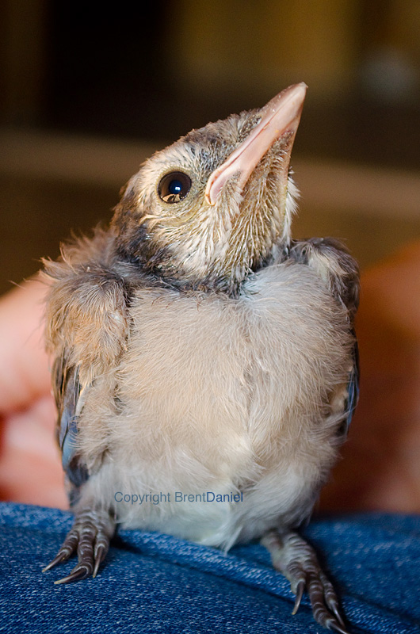

This is a fledgling Blue Jay. Fully feathered, yet unable to fly, this bird will hop around on the ground for days. Parents feed the fledgling on the go. A fledgling with parents present does NOT need rescued unless injured.

**When would a fledgling need rescued?**

* Obvious injury; bleeding
* Has flies, ants or other bugs crawling over it
* Has been in the mouth of a dog or cat
* Both parents are known dead
* Lethargic, weak, unable to stand or hold head up and is cold to touch
* Signs of neurological damage such as seizures, head tilting, walking in circles