|  |  |
| --- | --- |
| Fledgling Birds | ::Logos:CNB-Logo-Wide.pdf |

**Baby Birds** – To rescue or not to rescue?  That is an excellent question!

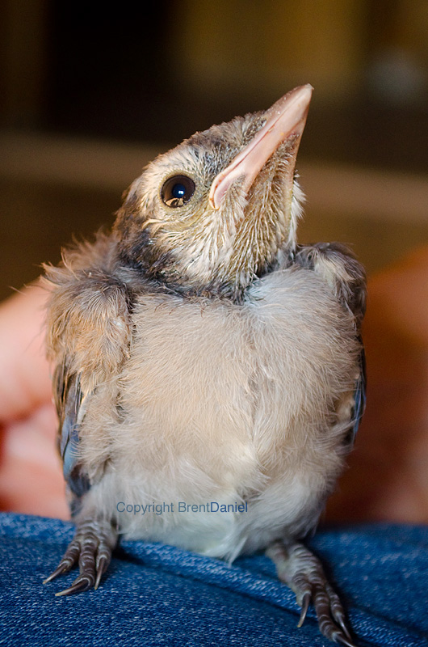

**Fledgling**

This is the stage of development that we receive the most calls about during the baby bird season.  **Fledgling songbirds leave the nest BEFORE they’re able to fly.**In much the same way human toddlers must crawl before they can run, songbirds hop and walk around a few days before they’re able to fly.  The majority of fledgling songbirds are well feathered on their body with short wing and tail feathers; they’re able to stand, walk and hop; they may be able to make short flights from branch to branch or from the ground up to low branches; and they are vocal and still dependent on their parents for care.  During this stage they are commonly observed on the ground, out in the open, on branches and in bushes - all over the place!

Although the parents may not be with their fledgling every second of the day, they remain in   
vocal contact at all times.  Additionally, the location where you observed the baby is the parents' territory, so they are always nearby.  It will take a few days to more than a week before fledgling songbirds can fly well enough to attempt to keep up with their parents and evade danger. The exception to this are swallows, swifts, flycatchers and all cavity nesting birds – these birds are fully feathered and flight capable when they leave the nest.  Any Fledgling swallows, swifts, flycatchers or cavity nesters that cannot fly must be rescued.  (There are also a number of cavity-nesting species which are also flight when they fledge the nest.) Need help with identification. Text us a photo to 303-618-0357 AND in a message to our Facebook account.

Fledglings are vulnerable and naïve at this stage of their development.  If you have outdoor cats, the kindest thing you can do for the birds is keep your cats indoors.  Remember, keeping cats indoors is safer for wildlife AND cats.

**When to Intervene**

Sometimes baby songbirds are genuinely in need of human assistance.  Below are guidelines to help you determine if a baby songbird needs your help.  Choose the circumstance below that best describe your situation that best describes your situation:

          
**I think a nest of baby songbirds or a fledgling songbird has been orphaned.**

Please follow these steps first, BEFORE you attempt a rescue:

·       Watch the nest or the youngster for at least one hour, non-stop.  Parent birds are fast and discreet when feeding their young.  So by taking your eyes off the baby or the nest for even a few seconds, you could miss the parents delivering a meal.

·       Observe at a safe distance away from the nest or the baby, at least 50 feet.  If you can view the birds from a place indoors, this is even better.  Parent birds will be wary to approach their baby if they know a predator (human, or otherwise) is in the vicinity.

·       Keep pets inside while you’re observing.  If you have a child observing with you, make sure they understand it is important to remain very quiet and still.

·       If you observe the parent birds delivering food and tending to their young, all is well.

·       If you are certain the baby/babies are abandoned, follow the instructions for “[Preparing a bird for transport](http://nativesongbirdcare.org/I_found_a_bird.html#anchor_transport)”.

 **I accidentally kidnapped a healthy baby bird:**

Are you a kidnapper?  After reviewing the information above about normal baby bird stages and deciding that the baby bird you found is healthy and doing what is normal for its age, then please put the baby back where you found it if it is a healthy fledgling.  I**t is a myth that songbird parents will reject their baby if a human has touched it**.  More than anything, parent birds want their baby back so that they can continue raising it, with the goal of perpetuating the existence of their species.

If you found a healthy fledgling in a dangerous area, like the middle of a road or sidewalk, carefully pick the fledgling up and place it in or under a bush or on the lowest branch of a tree that is closest to where you found it.  Make sure predators, such as cats, have been cleared from the area.  Observe from a safe distance to be sure the parents have returned to care for their baby.

**I found a baby songbird** that has had contact, or suspected contact, with a cat or dog.

Even if you can’t find any injuries, you need to bring the bird to a licensed wildlife rehabilitator for care.  The tiniest puncture wound, especially from a cat, quickly introduces lethal bacteria into a bird’s body.

**I found a sick or injured Fledgling.**

Any of these signs warrant rescue:

* That appears lethargic, weak, unresponsive, cannot lift head, or is cold.
* Which has a strange odor.
* With feathers contaminated, dirty or appear wet and matted down.
* That has poor balance, seizures, cannot turn head straight, cannot stand up or grip with feet, or is shaking.
* With eyes or nostrils that appear infected or bloody.
* Whose droppings are liquid and white or bright green.
* That has bugs, ants, flies crawling all over it.
* Of which one or both of the parents are known to be dead.

If the bird exhibits any of the signs above, rescue it immediately, and follow the instructions to “[Prepare a bird for transport](http://nativesongbirdcare.org/I_found_a_bird.html#anchor_transport)”.

**NOTE:**Without proper licenses from State Departments of Fish and Game and US Fish and Wildlife Services, it is unlawful to possess a live or dead native bird, feather or egg. Please refer to Colorado Department of Parks and Wildlife and The Federal Migratory Bird Act for more info.

Wild native songbirds have very specific dietary needs, requirements for housing, care and release back to the wild.  The internet is filled with misinformation, even some grossly irresponsible information, and should not be utilized for advice about hand-raising any wildlife.  It is also important to remember that raising wild native birds is in no way similar to raising domestic pet birds, regardless of advice provided by a health professional for domestic animals or a pet store.  Baby birds that are raised by well-meaning, but misinformed untrained people result in very poor health, disease and often irreversible habituation and/or imprinting. These things  will lead to the unfortunate and unnecessary death of the bird.  So, if you’ve taken the first step to do the right thing for the bird by rescuing it, please complete the process and bring it to a licensed wildlife facility where it can receive proper medical and supportive care by a trained professional.

If you find an injured, orphaned or ill bird, please call us so that we may provide the proper medical care by our fully licensed wildlife rehabilitator. Donna Nespoli of Colorado Native Bird Care and Conservation (CNBCC) has current state and federal licenses to care for birds and small mammals.